Root Cause is a streetwear clothing brand that creates pieces that embody current and powerful trends and designs, we are driven to create pieces that portray our unique and aesthetic designs.

Our goal at Root Cause is to provide high-quality and affordable clothing for people of all ages around the world. We at Root Cause believe in creating collections that demonstrate our intention and longevity with timeless pieces. We strive to take a stand against some of these clothing companies that don’t use our same practices in the fashion industry. We offer a large range of premium products and collections that collaborate with multiple brands with the same mentality.

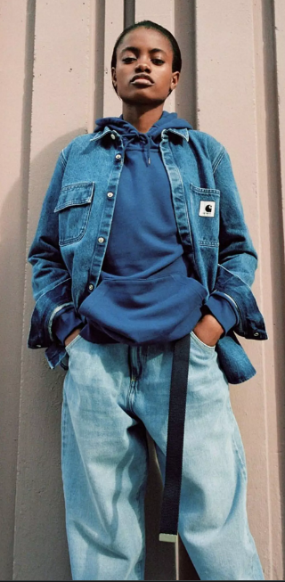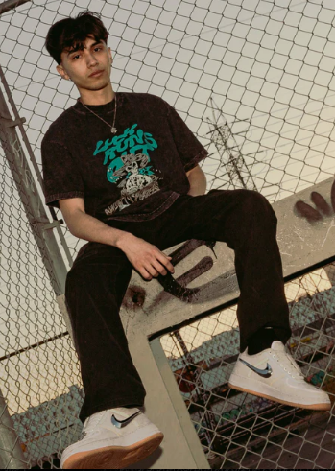**PERSONAS**

Name: Aubree Ventura

Age: 30

College

An influencer that works with brands to promote and sell products.

Name: Hector Diaz

Age: 22

High School/College

Into street fashion, streetwear brands, and willing to pay

**COMPS**